Leave two blank lines

Title of the abstract (Times Roman 14 pt, bold)
Leave one blank line
A. Author1¹, B. Author2², C. Author3¹ (Times Roman 12 pt, bold)
Leave one blank line
¹Affiliation University1 (Times New Roman 10pt, italic),
²Affiliation University2 (Times New Roman 10pt, italic),
e-mail: of communicating author@institution.ac.at
Leave two blank lines

Leave two blank lines before the text body. Text font: Times New Roman, 12 pt; line spacing: 14 pt, justified; document margins: 2.5 cm top and bottom, 2.5 cm left and right (format A4). The abstract (including figures, see below) must not exceed two pages in length. No blank line between paragraphs. New paragraphs are intended (12 mm).
References should be cited in the text as follows: relevant information can be found by Strunz & Nickel (2001), Streckeisen (1967) – alternatively in brackets (Beran et al. 1983) respectvely (Zemann, 1948; Jäger, 1962). Leave two blank lines before the reference list but do not give a subtitle to the list. Font size of the reference list: 10 pt, line spacing: 12 pt, justified.
Figures / Tables, should be cited as Fig. 1 / Tab. 1 etc. in the text. Figure / table caption(s) are labelled as Figure 1 / Table 1 etc. and should be placed below the figure / above the table. Font size of the captions: 10 pt, line spacing: 12 pt, justified.
Abstracts should be sent to minwien2023.mineralogie@univie.ac.at (conference e-mail address). Please upload the abstract as a docx (doc) file with embedded figures and tables (if required).
Table 1. Minerals crystallising in the zemannite-type structure (font size 10 pt.)

Ilirneyite
Mg_{0.5}[ZnMn³⁺(TeO₃)₃]∙4.5H₂O

Keystoneite
Mg_{0.5}[(Ni, Fe,Mn)₂(TeO₃)₃]∙4.5H₂O

Kinichilite
Mg_{0.5}[(Mn²⁺,Zn)Fe³⁺(TeO₃)₃]∙4.5H₂O

Zemannite
Mg_{0.5}[ZnFe³⁺(TeO₃)₃]∙4.5H₂O
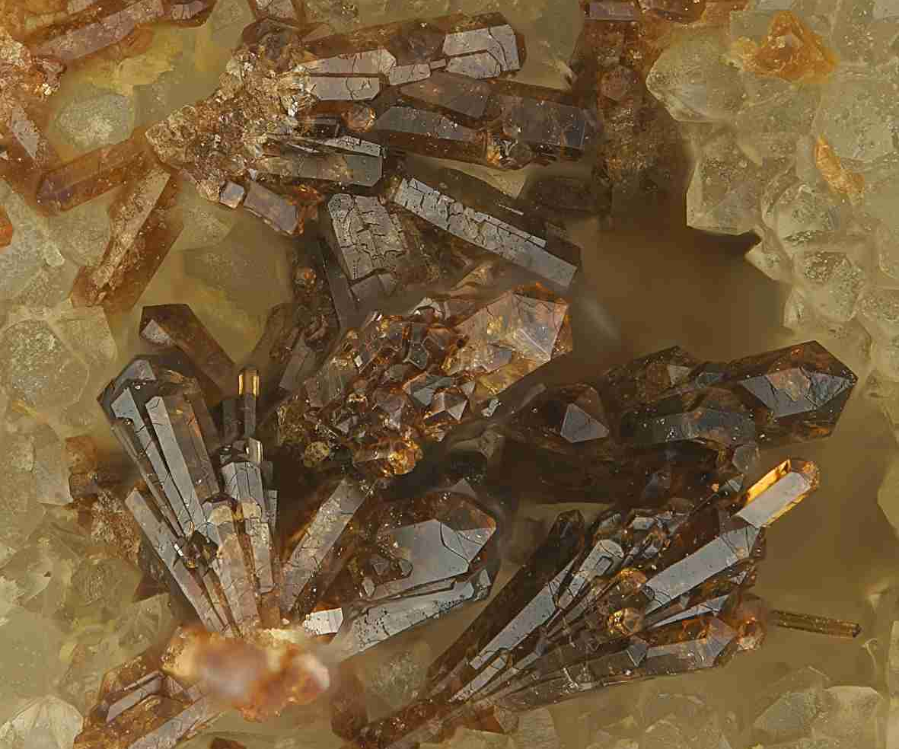

Figure 1. Zemannite - the mineral of the meeting
Foto: S. Wolfsried (font size 10 pt.)
Leave two blank lines

Beran A, Hafner St, Zemann J (1983): Untersuchungen über den Einbau von Hydroxylgruppen im Edelstein-Sillimanit. - N Jb Mineral Monatsh 983, 219
Jäger E (1962): Rb-Sr age determinations on micas and total rocks from the Alps. - J Geochem Res 67, 5293
Streckeisen A (1967): Classification and nomenclature of igneous rocks. - N Jb Mineral Abh 107, 144
Strunz H, Nickel EH (2001): Strunz mineralogical tables. - Schweizerbart, Stuttgart
Zemann J (1948): Formel und Strukturtyp des Pharmakosiderits. - Tschermaks Miner Petrogr Mitt 1, 1

Please add – many thanks:

---- Name of the abstract file: ...............................................
The abstract file should be named according to the first author’s last name (e.g., Zemann.docx). Only doc or docx formats are accepted. The abstract should be sent as an attachment to an e-mail to minwien2023.mineralogie@univie.ac.at

---- Presenting author: ...............................................

Please indicate your preferences for the presentation of your contribution:

---- Preferred presentation:  Oral  Poster

---- Preferred session of the contribution
first - second
choice
Young Scientist Session.
Chairs: L. Czekay (Bayreuth), R. Volkmann (Potsdam)  

Metal enrichment processes - latest advances in the understanding of ore formation.
Chairs: M. Wilke (Potsdam), J. Michaud (Hannover), M. Korges (Potsdam)  

The co-evolution of Earth's atmosphere, oceans, continents, and life from the
early Archean until today.
Chairs: S. Viehmann (Hannover), A.S. Rodler (Vienna),
S.V. Hohl (Shanghai, China)  

Carbonates in natural and technical environments – Precipitation mechanisms,
monitoring and applications.
Chairs: R. Boch (Graz), P. Németh (Budapest, Veszprém),
M. Dietzel (Graz)  

Interplay of chemical and mechanical processes across scales.
Chairs: S. Schorn (Graz), A. Rogowitz (Graz)  

Chronology of geological processes: past, present, future.
Chairs: D. Gallhofer (Graz), E. Skrzypek (Graz)  

Spectroscopic methods in modern geosciences.
Chairs: M. Kaliwoda (Munich), J. Göttlicher (Eggenstein-Leopoldshafen)  

Linking microstructures, crystallographic textures, and the nature of interfaces.
Chairs: T. Griffiths (Wien), G. Habler (Wien)  

Crystallographic Materials Science: from basics to application.
Chairs: S. Schorr (Berlin), C. Weidenthaler (Duisburg-Essen)  

Structure-property relationships of minerals and beyond - Minerals as advanced materials.
Chairs: M. Münchhalfen (Bochum), J. Schreuer (Bochum)  

You do not find a suitable session for your abstract here - please suggest an additional microsymposium. The list of sessions is completed regularly at https://minwien2023.univie.ac.at/abstracts.html
---- Further session topics – please mark your preferences
(first and second choice)

Mineralogy and Crystallography  
Properties of minerals & materials - Physics and chemistry of minerals
Crystal structures of minerals and related compounds
Topology and modular aspects of crystal structures - Aperiodic & quasi-crystals
(New) minerals and mineral classification
Phase transitions and high-pressure / high-temperature mineralogy
Neutron and electron scattering – Microstructures & textures of minerals
Recent analytical developments used in the Earth sciences

Applied and Technical Mineralogy  
Environmental mineralogy and technical applications
Forensic mineralogy - archeometry and cultural heritage
Cements, ceramics, glasses and building stones
Biomineralogy and biomineralization
Mineralogical aspects related to climate change (carbon cycle)

Environmental and medical mineralogy  
Biosphere-geosphere interactions: environmental aspects
Weathering, dissolution, adsorption, and transport processes
Developments and applications of analytical methods
Stable isotopes in biogeochemistry: experiment and theory
Biogenic substances - CO₂ cycle and storage - anthropogenic environments
Biogeochemical interfaces and environmental mineralogy

Petrology and Geochemistry  
From melts to rocks and P-T evolution of rocks
Timing and duration of metamorphic events and reactions
Transport reactions, fluid―mineral―rock interactions and interfaces
Stable and radioactive isotopes: clocks & tracers of rock formation/evolution
Geochronology and petrochronology - fluid processes in the crust and mantle
Sedimentology and weathering of rocks - thermodynamics and phase equilibria
Experimental mineralogy, petrology and geochemistry - the deep Earth and beyond
Astromineralogy, early solar system and the mineral record of impact events

Economic Geology and Ore Deposits  
Raw materials & metals - Industrial, economic and ore minerals
Critical geomaterial - (Deposit) modelling and mapping
Geometallurgical aspects in the beneficiation of metallic ore deposits
Genesis of ore & mineral deposits - Field studies - Supergene enrichments

Open Sessions  
Computer programmes - gemmology and gemstones
Mineral history & teaching - mineralogical museums and collections
Other general aspects of mineralogy, petrology, and geochemistry

